**Auto Marking Program Guideline**

**Things to do for Web Server**

1. You have to handle message received from Web client with multi thread(Iteration Structure, Single Thread Structure is not acceptable)
2. There is a lot of ERROR CODE on HTTP; however, we are going to mark 3 codes 200 OK, 404 NOT FOUND, 400 BAD REQUEST(in 400 BADD REQUEST case, you just need to handle HTTP/1.1 Protocol. If Client send request message as HTTP/1.0 Protocol version you should send 400 BAD REQUEST. It is what you have to do for 400 ERROR CODE)
3. You have to make 2 Pages(First Page: Index, Second Page: Image, You can build pages as different names)
   1. First page header should be text/html and 1024 length
   2. Second page header should be image/jpeg and 1024 length
   3. This conditions are for testing criteria
4. You have to set HTTP header Content Length as ‘1024’, and Content Type as text/html for first page, Image/jpeg for second page

**List of grading items**

1. Socket & Program Handling
   1. Web Server socket is opened normally
   2. Multi Thread – Web Server should handle message with multi thread on each messages
2. Restful API
   1. You just need to implement ‘GET’ method
3. ERROR Handling and response appropriate with response code
   1. 200 OK: You should response 200 OK when Web Client approach correct URL that you assign on Web Server
   2. 404 NOT FOUND: You should response 404 NOT FOUND if Web Client approach WRONG URL that you don’t assign on Web Server
   3. 400 BAD REQUEST: If Client send you request with HTTP/1.0 Version, you should send 400 BAD REQUEST.
4. HTTP Header Handling CheckD
   1. Content Length: We set Content Length as ‘1024’ so as to check if you can handle http header or not
   2. Content Type: text/html (first Page), image/jpeg (second Page)

**How to test?**

* + 1. Approach *166.104.143.225/index* through your web browser (Internet Explorer, Chrome, Firefox and etc.). Next move to “Computer Network” and click “Go Test”(Student manual is right next to “Go Test”).

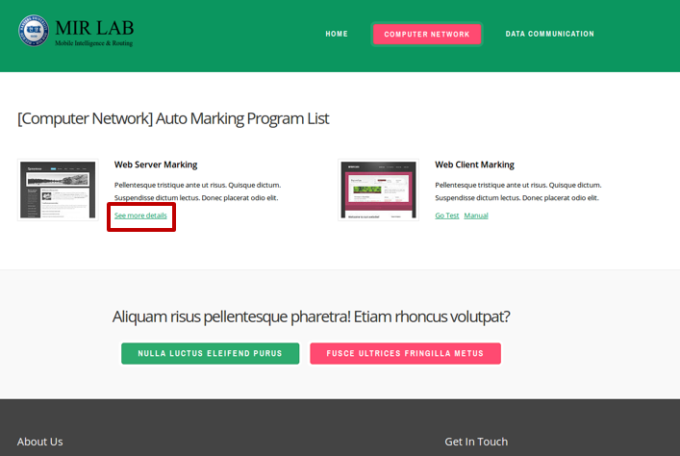

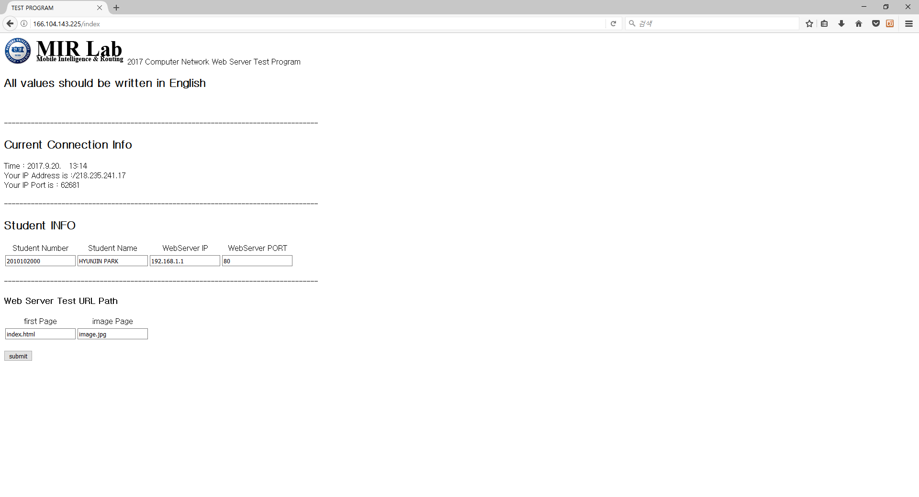

* + 1. Fill in the blanks
       - 1. Student Number(2017xxxxx)
         2. Student Name (Should be written in English)
         3. Your Web Server IP Address. If you are hard to find your global IP, refer to Current Connection Info in case you approaches this web site with the same computer
         4. Port that you assign for your Web server, Check this out on your Source Code
         5. First Page that your text/html is located
         6. Second Page that your Image/jpeg is located
    2. ERROR Page

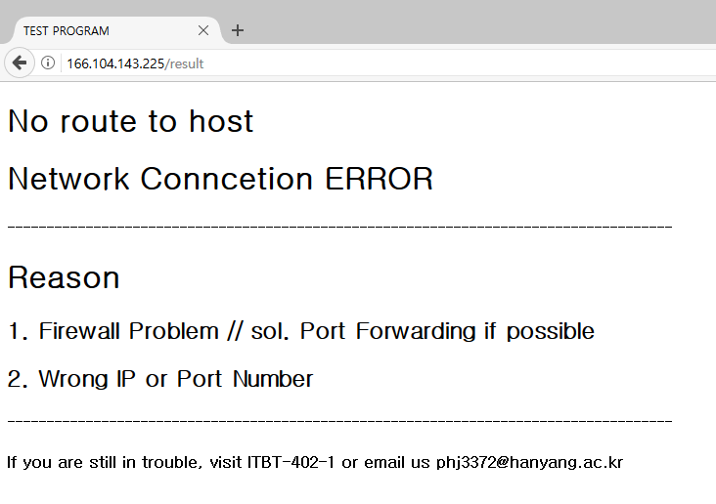

If you confront this page, 2 main reasons are Firewall problem or you had put Wrong Web Server IP Address or Port Number.

1. Firewall problem: You have to forward your port through Router. Most routers are available to forward specific port number; however some Router is impossible to forward part because of Telecom policy, in this case visit ITBT/402-1 and test it as local address.
2. Check your Web Server IP address or Port

* + 1. Result Page

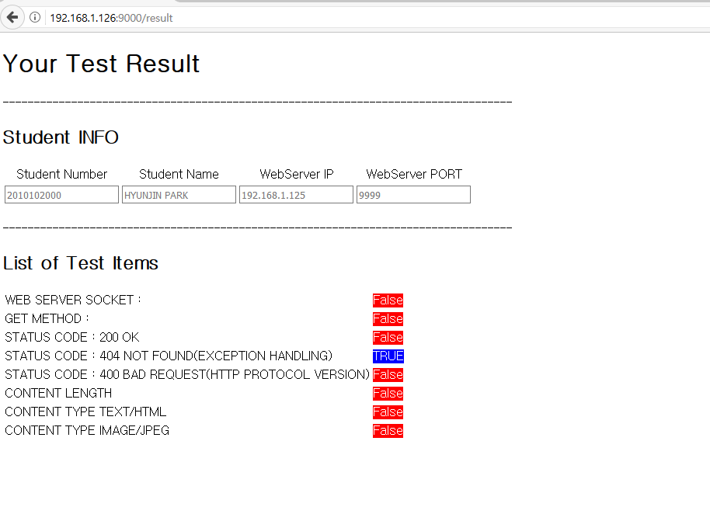

1. You can see what is wrong or correct with Reason